Alan Fetter Kreider was born November 8, 1941 in Goshen, Indiana, the son of Carl and Evelyn (Burkholder) Kreider, and died at home in Goshen on May 8, 2017.
A lifelong scholar, Alan graduated from Goshen College in 1962. After earning his PhD in English History at Harvard University, Alan returned to teach history at Goshen College. Alan married Eleanor Graber Nase on June 19, 1965, in Goshen. In 1974, Alan and Eleanor moved to London, England, to serve with the Mennonite Board of Missions, where they were directors of the London Mennonite Centre and spoke in churches and colleges around the country. In the 1990s, they moved to different parts of England, first to Manchester, and then in 1995 to Oxford. Throughout these years, they taught in theological colleges, spoke at conferences and helped to establish a new Anabaptist Network. They developed a distinctive style of shared public speaking. In 2000, Alan and Eleanor returned to live in Elkhart, where Alan taught church history and missions courses at Anabaptist Mennonite Biblical Seminary. He was named Professor Emeritus of Church History and Mission by AMBS in October 2014.
Alan is survived by his wife Eleanor and son Andrew (Katie Bast) of Elkhart, two siblings, Rebecca (Weldon) Pries of Cambridge, Massachusetts, and Thomas Kreider of Goshen, Indiana, and three grandchildren, Joseph, Daniel and Eleanor Rose Kreider. His brother Stephen died in 2014. His legacy is seen in his writing and in the lives of the many people for whom he was a trusted mentor.
One friend recently wrote to Alan: Thank you for pointing to and articulating The ‘Way.’ We will miss the books you had hoped to write but we will long remember words that you filled with deeper and richer meaning: worship, peace, baptism, Christendom, catechism, formation, patient ferment, habitus and more. You had a wonderful way of making a point but not overselling it. The salt never lost its savor.

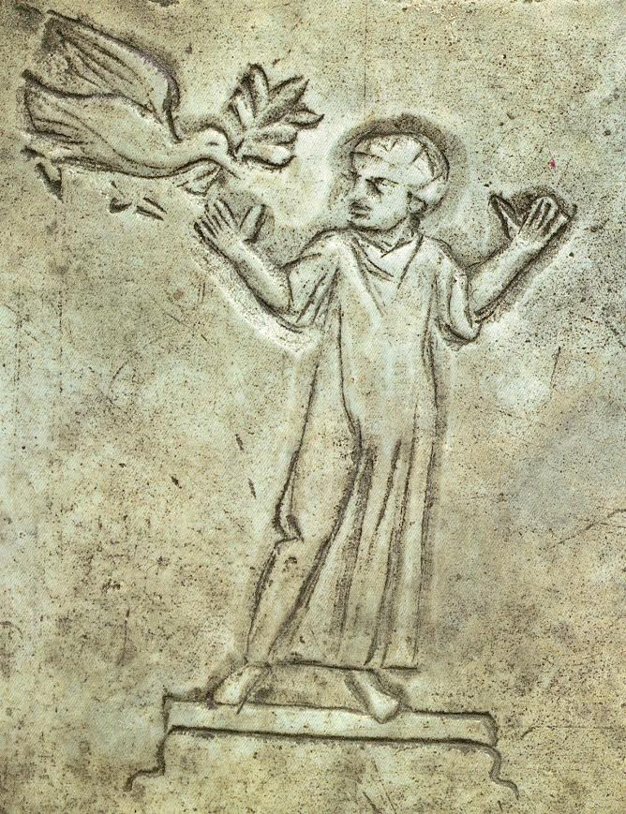

The Kingdom of God is justice, peace
and joy in the Holy Spirit.
Romans 14:17

A Service of Worship & Thanksgiving
for the life of Alan Kreider

Prairie Street Mennonite Church, Elkhart, IN

Tuesday, May 16, 2017

Part One

Preservice music

Opening Scriptures

Prayer

Hymnal 37 Praise to the Lord, the Almighty

Reading of the obituary

Hymnal 76 Praise, I will praise you, Lord

Psalm 84:1-4

How lovely is thy dwelling place traditional Scottish melody

John 10:14-17

Sermon Ephesians 1:3-12, 15-18

Prayers

Hymnal 581 Take thou my hand, O Father

Prayer of Commendation

Music for reflection* Song of Simeon

Benediction

Postlude music

Worship Participants

Prairie Street Mennonite Pastors: Nelson Kraybill, Carolyn Gardner Hunt, Frances Ringenberg
Preacher: Larry Miller, General Secretary of the Global Christian Forum, Alan’s lifelong friend and colleague
Musicians: Andrew Kreider, John Sommers, Kyle Weirich, Carol Weirich, Lauren Weirich

Part Two

All are welcome to join the family for an English tea time and storytelling following the worship service.

